[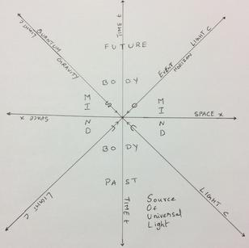](http://www.abcdefg.co/everything.html)

[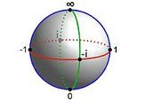](https://en.wikipedia.org/wiki/Riemann_sphere)

[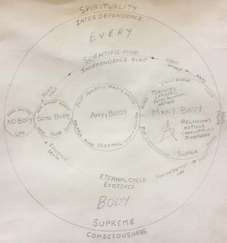](http://www.abcdefg.co/consciousness.html)

[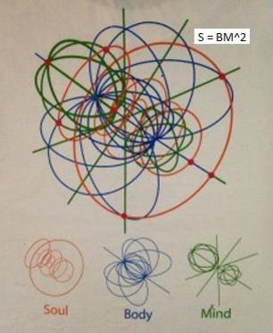](https://en.wikipedia.org/wiki/3-sphere)

[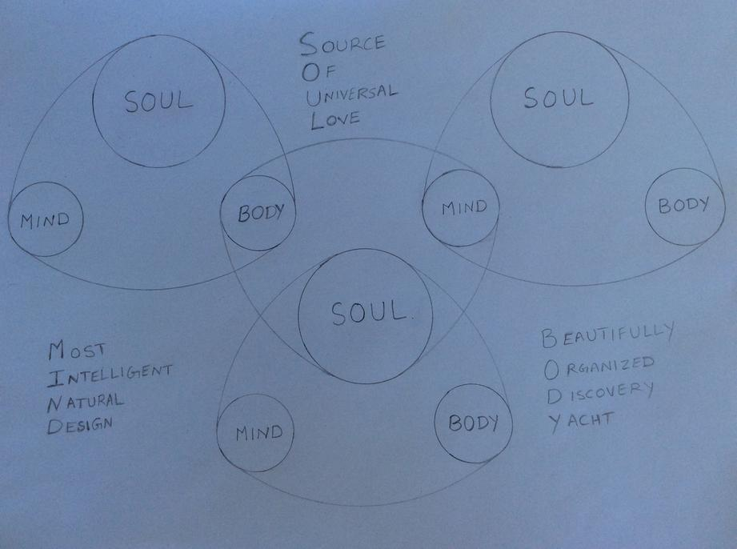](http://www.abcdefg.co/soulmindbody.html)

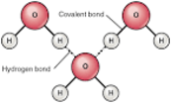

[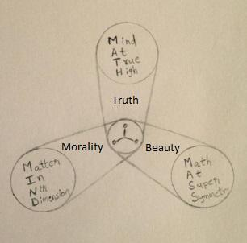](http://www.abcdefg.co/aligninstillsustain.html)

[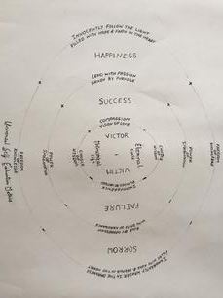](http://www.abcdefg.co/usem.html)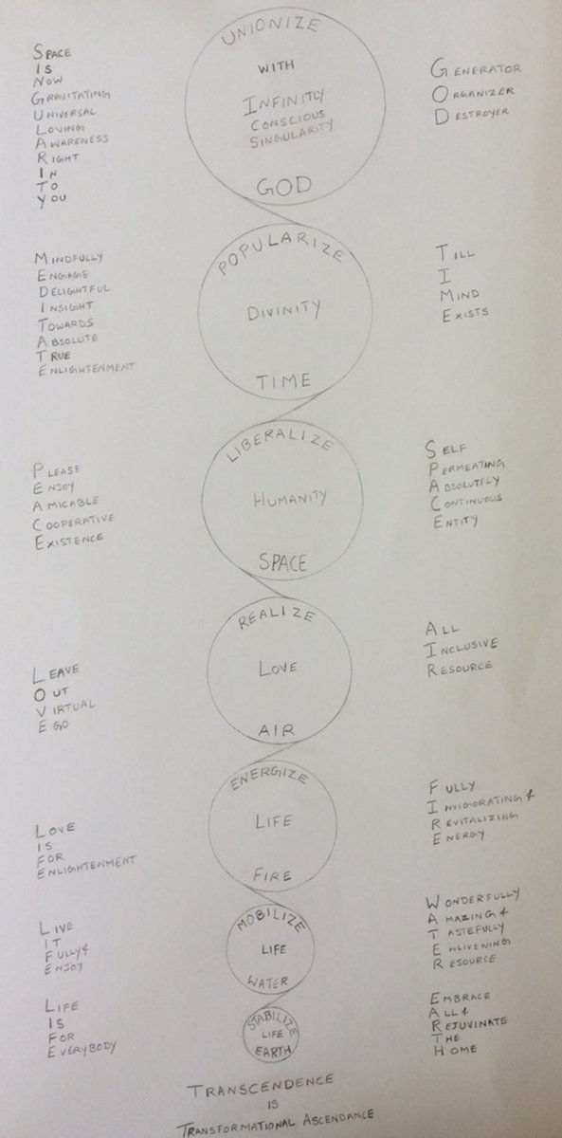

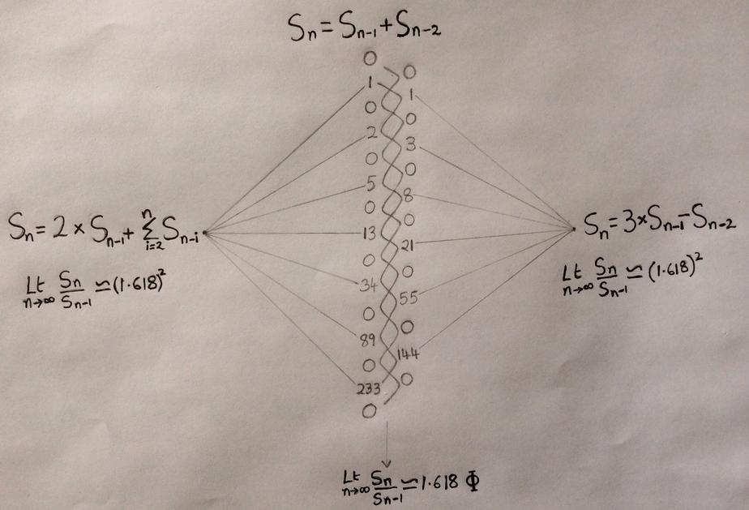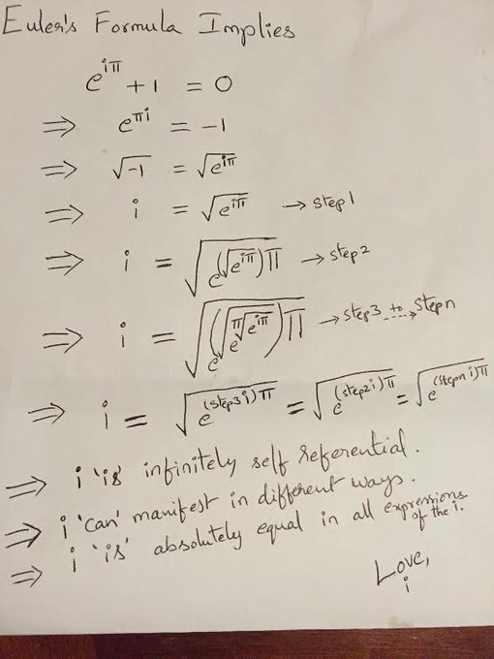 [](http://www.abcdefg.co/everything.html)